ALBERT A Contact: 0091 8903444728 / 8220890534 (India) 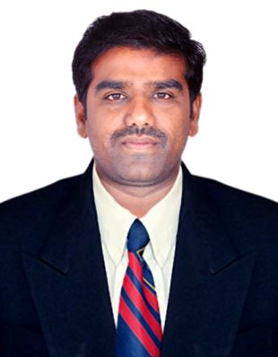
E-Mail: albertaline918@gmail.com / albert_msc@yahoo.co.in
PROFILE SUMMARY
- Having exceptional interpersonal, communication and motivational skills
- HACCP Audit (ISO 22000 FSMS) certificate holder
- Hand on Experience in Fish Farming
- Knowledge of Marketing business and Management Principles involved in Strategic Planning, Resource allocation, Leadership Technique and Coordination of people and resources.
- Self-motivated with a flexible attitude, and able to adapt quickly to change.
- Leading, engaging and building confidence in Team members .
- Proven ability to stay within approved budgets schedules & achieves the objectives.
- Coordination skills to develop a cordial relationship with other departments as well as Project staff.
- Expertise in team work, Rational thinking, Ability to work in multidisciplinary setting, Knowledge on current social issues, Leadership quality, Listening & reading skills
- Languages known – Tamil, English(Write & Speak)
Telugu, Malayalam, Hindi(speak)
ORGANIZATIONAL EXPERIENCE
Currently working as Area Manager in a Private sector for the marketing of prawn feed supplements

NOVEMBER’2015 – APRIL’2017 with Fish Farm LLC, Dubai, United Arab Emirates as Assistant Manager

FEBRUARY’2009 – OCTOBER’2015 with Al Faris Group – Caviar Aquaculture, Dammam, Kingdom of Saudi Arabia as Manager

MARCH’2007 - FEBRUARY’2009 with Rajiv Gandhi Centre for Aquaculture (RGCA) as Assistant Technical Manager

MAY’2003 - MARCH’2007 with Grobest Feeds Corporation (I) Ltd as Technician
EDUCATION
AUG.2001 – MAR.2003 :- M.Sc. (Aquaculture) with First Class
University of Madras, Chennai
Tamilnadu, South India.
AUG.1998 – APR.2001 :- B.Sc. (Zoology)
Bharathidasan University
Tiruchirapalli, Tamilnadu
South India.
TRAININGS ATTENDED
- LEAP – Leadership Education and Awareness Programme 12.10.2000 to 14.10.200 & 31.03.2001 held at Dharmapuram, Nagapattinam District, Tamilnadu
- The State Level Seminar On Food Processing, P.G. Department of Zoology, Yadava College & Min. of Food Processsing Industries, New Delhi. Held on 23,24 & 25 Aug.2000 at Madurai, Tamilnadu
- Training in HACCP AUDIT (ISO 22000.FSMS) at CIFT from 01.01.2009 to 05.01.2009(4days)
EXTRA CURRICULAR ACTIVITIES
- NCC – National Cadet Corps 8,Tamilnadu, Bn. NCC. August 1998 to March 2001
Certificates B (Passed Year 2000) and C (Passed Year 2001)
- NSS – National Service Scheme
Attended Two Camps
PERSONAL DETAILS
Date of Birth : 26th July, 1979
Passport Details : M 2249069
Permanent Address : Plot No.137,First Cross, Kothari Nagar, Keezhakasakudy,
Karaikal – 609 609, UT of Puducherry
Nationality : Indian
Marital Status : Married
No. of Dependants : 2
DECLARATION

I hereby declare that the details furnished above are true to the best of My Knowledge and belief.

Place : Karaikal
Date : 09.03.19 Albert. A

